**Jennie Award 2024 – 2026**

Mary Jo Thomas, Chairman

512 Front Street

Fairmont, WV 26554

maryjowv@comcast.net

304.534.8258 (h) 202.365.7510 (c)

So looking forward to receiving lots of entries from our clubs for Jennie Award Winners for the 2024 - 2026 administration. We have so many wonderful, dedicated, capable and caring Clubwoman who are deserving of Jenny nomination and recognition.

I am only a phone call or email away and will be happy to help as you work through the nominating process.

When we had to go to print new material had not been received. These will be shared with you as materials become available.

To get you started thinking and planning for your club’s nomination, information from the GFWC 2024 - 2026 Jennie Award Contest which was in the club manual is included.

Forms and a calendar of deadline dates will get shared when available. The information included describes the award and criteria which should help you get started. Decide on your nominee and start gathering your information.

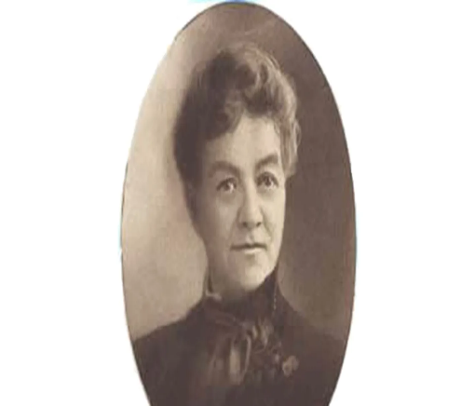We know how great our Clubwoman are. Let’s share their wonderful accomplishments and caring endeavors with the rest of GFWC by nominating them for the Jennie Award for the 2024 - 2026 administration.

Good Luck! Happy Jennie Entry! Enjoy the Journey!

Mary Jo

